Xin Zhao

Professor David Klappholz

CS 561 WS

08/12/2021

Final Exam

1. Translate the following ER diagram into an equivalent minimal storage relational design. (Be sure to include all necessary keys and foreign key references.)

Sol:

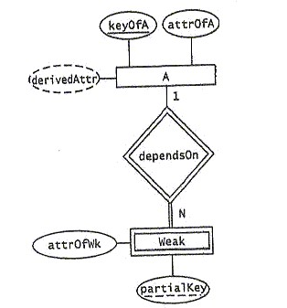

Minimal storage translation:

A

|  |  |
| --- | --- |
| attrOfA | keyOfA |

Weak

|  |  |  |
| --- | --- | --- |
| attrofWk | partialKey | keyOfA |

1. Translate the following ER diagram into an equivalent minimal storage relational design. (Be sure to include all necessary keys and foreign key references.)

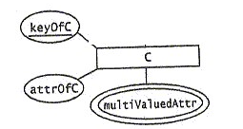

Sol:

Minimal storage translation:

C

|  |  |
| --- | --- |
| attrOfC | keyOfC |

C_multivaluedAttr

|  |  |
| --- | --- |
| keyOfC | multivaluedAttr |

1. Translate the following ER diagram into an equivalent minimal storage relational design. (Be sure to include all necessary keys and foreign key references.)

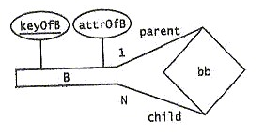

Sol:

Minimal storage translation:

B

|  |  |  |
| --- | --- | --- |
| attrOfB | keyOfB | keyOfB_parent |

1. Translate the following ER diagram into an equivalent minimal storage relational design. (Be sure to include all necessary keys and foreign key references.)

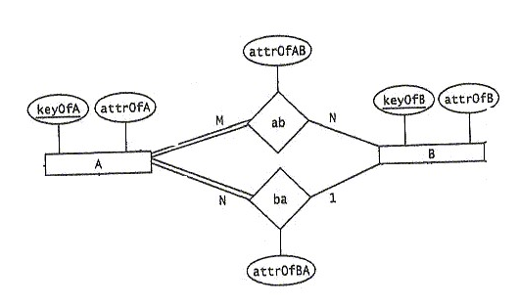

Sol:

Minimal storage translation:

A

|  |  |  |
| --- | --- | --- |
| attrOfA | keyOfA | attrOfBA |

B

|  |  |
| --- | --- |
| attrOfB | keyOfB |

ab

|  |  |  |
| --- | --- | --- |
| keyOfA | keyOfB | attrOfAB |

1. 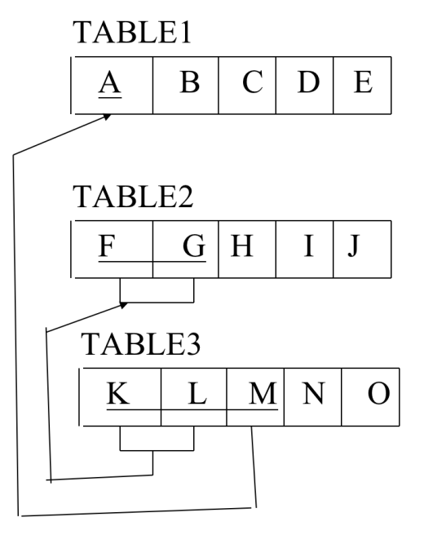Translate the following relational design into an equivalent ER diagram.

Sol:

